City of 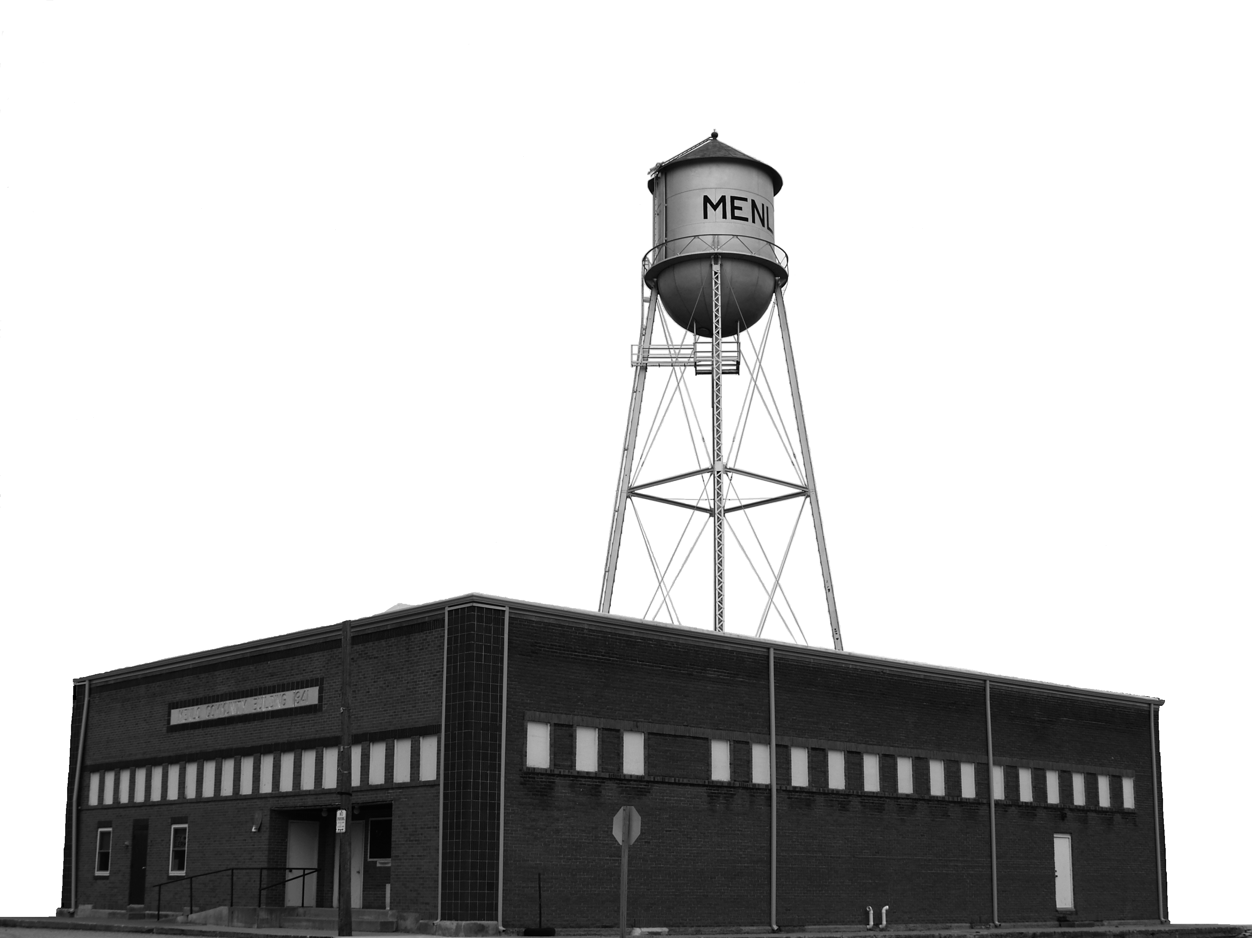 Menlo
417 Sherman Street Phone: (641) 524-2411
PO Box 190 Fax: (641) 524-4000
Menlo, Iowa 50164 Email: menloia@netins.net ________________________________________________________________________________________________________

To Whom It May Concern:

All Menlo City Campsite occupants are required to pay the fees in advance. However, if you are staying for an extended period, we realize that you may not know the end date of your stay. We need all campers paid in full for each month at the beginning of the month of your stay and then prior to departure to avoid any issues.

The Menlo Maintenance Supervisor usually flushes and turns on the campground water April 1st and turns it off in November. However, he will keep the water on until there are no campers still using it in November. If you plan to arrive before April 1st and/or stay after November 30th, please come to the Clerk’s office to make further arrangements.

Camping Fees are $25.00 per night, except site #5. Site #5 is $18.00 per night and does not have sewer. If you do not remember the date of your arrival, please contact the City Clerk. Please fill out the following form and submit it with your payment in the drop box or the clerk’s office. Thank you for your cooperation in this matter.

Katie Reynolds
Menlo City Clerk

Campground Registration Form
Site # ____________ ______________
Name:________________________________________________________________________ Address:______________________________________________________________________Phone: ______________________________________Cell_____________________________
Type of Camper: ________ _______________________________________________________ Vehicle License Plate Number___________________________________________________ Arrival Date: ___________________Departure Date: ________________________________
Amount Paid at $25.00 Per Night: ___________________________________Cash or Check (circle one)

